|  |
| --- |
| E:\AVPTI\ISRO\Logos_RKM\avpti.png  **To-Do List Application**  **Affiliated to Gujarat Technological University** |
| SEMESTER 5 COMPUTER ENGINEERING DEPARTMENT WBJP (4350708) |
| MICRO PROJECT TITLE To-Do List Application  STUDENTS’ GROUP DETAILS     |  |  | | --- | --- | | 216020307035 | Mungra Raj A. | | 216020307126 | Padiya Chirag H. | | 216020307171 | Zalavadiya Parth B. | |
|  |

**Introduction**

The **To-Do List Application** is a simple yet efficient web-based task management system developed using JSP (JavaServer Pages), HTML, CSS, and a MySQL database. It allows users to add, edit, delete, and mark tasks as completed. The goal of this project is to create a lightweight, user-friendly application without using Java Servlets. The tasks are stored in a MySQL database, and users can perform CRUD operations on tasks directly through JSP pages.

This project demonstrates the use of JSP pages for server-side logic and interaction with a MySQL database, with no Servlets involved. It also provides a simple, elegant user interface for managing tasks.

**Code**

**1. WEB-INF/web.xml**

This configuration file sets the welcome page (index.jsp).

xml

Copy code

<?xml version="1.0" encoding="UTF-8"?>

<web-app xmlns="http://java.sun.com/xml/ns/javaee"

xmlns:xsi="http://www.w3.org/2001/XMLSchema-instance"

xsi:schemaLocation="http://java.sun.com/xml/ns/javaee

http://www.w3.org/2001/XMLSchema-instance/web-app\_3\_0.xsd"

version="3.0">

<welcome-file-list>

<welcome-file>index.jsp</welcome-file>

</welcome-file-list>

</web-app>

**2. db.jsp**

This file handles the database connection.

jsp

Copy code

<%@ page import="java.sql.\*" %>

<%

String url = "jdbc:mysql://localhost:3306/todo\_list\_db";

String username = "root";

String password = "password";

Connection conn = null;

try {

Class.forName("com.mysql.jdbc.Driver");

conn = DriverManager.getConnection(url, username, password);

} catch (Exception e) {

e.printStackTrace();

}

%>

**3. add.jsp**

This page handles adding new tasks.

jsp

Copy code

<%@ include file="db.jsp" %>

<%@ page import="java.sql.\*" %>

<!DOCTYPE html>

<html>

<head>

<link rel="stylesheet" href="styles.css">

<title>Add New Task</title>

</head>

<body>

<div class="container">

<h2>Add New Task</h2>

<form action="add.jsp" method="post">

<input type="text" name="task\_name" placeholder="Task Name" required />

<textarea name="task\_description" placeholder="Task Description"></textarea>

<input type="date" name="due\_date" required />

<button type="submit" name="add\_task">Add Task</button>

</form>

<a href="index.jsp" class="btn">Back to To-Do List</a>

</div>

<%

if (request.getParameter("add\_task") != null) {

String taskName = request.getParameter("task\_name");

String taskDescription = request.getParameter("task\_description");

String dueDate = request.getParameter("due\_date");

String insertTask = "INSERT INTO tasks (task\_name, task\_description, due\_date) VALUES (?, ?, ?)";

PreparedStatement ps = conn.prepareStatement(insertTask);

ps.setString(1, taskName);

ps.setString(2, taskDescription);

ps.setString(3, dueDate);

ps.executeUpdate();

response.sendRedirect("index.jsp");

}

%>

</body>

</html>

**4. index.jsp**

This file displays the task list, allowing users to view, edit, delete, or mark tasks as completed.

jsp

Copy code

<%@ include file="db.jsp" %>

<%@ page import="java.sql.\*" %>

<!DOCTYPE html>

<html>

<head>

<link rel="stylesheet" href="styles.css">

<title>To-Do List</title>

</head>

<body>

<div class="container">

<h2>To-Do List</h2>

<a href="add.jsp" class="btn">Add New Task</a>

<table border="1">

<tr>

<th>Task</th>

<th>Description</th>

<th>Due Date</th>

<th>Status</th>

<th>Actions</th>

</tr>

<%

String selectTasks = "SELECT \* FROM tasks WHERE status = 'Pending'";

PreparedStatement ps = conn.prepareStatement(selectTasks);

ResultSet rs = ps.executeQuery();

while (rs.next()) {

%>

<tr>

<td><%= rs.getString("task\_name") %></td>

<td><%= rs.getString("task\_description") %></td>

<td><%= rs.getDate("due\_date") %></td>

<td><%= rs.getString("status") %></td>

<td>

<a href="edit.jsp?task\_id=<%= rs.getInt("task\_id") %>">Edit</a> |

<a href="index.jsp?delete\_task=<%= rs.getInt("task\_id") %>">Delete</a> |

<a href="index.jsp?complete\_task=<%= rs.getInt("task\_id") %>">Mark as Completed</a>

</td>

</tr>

<%

}

%>

</table>

<%

// Delete Task

if (request.getParameter("delete\_task") != null) {

int taskId = Integer.parseInt(request.getParameter("delete\_task"));

String deleteTask = "DELETE FROM tasks WHERE task\_id=?";

PreparedStatement psDelete = conn.prepareStatement(deleteTask);

psDelete.setInt(1, taskId);

psDelete.executeUpdate();

response.sendRedirect("index.jsp");

}

// Mark Task as Completed (removes completed tasks)

if (request.getParameter("complete\_task") != null) {

int taskId = Integer.parseInt(request.getParameter("complete\_task"));

String markCompleted = "UPDATE tasks SET status='Completed' WHERE task\_id=?";

PreparedStatement psComplete = conn.prepareStatement(markCompleted);

psComplete.setInt(1, taskId);

psComplete.executeUpdate();

String removeCompleted = "DELETE FROM tasks WHERE status='Completed'";

PreparedStatement psRemove = conn.prepareStatement(removeCompleted);

psRemove.executeUpdate();

response.sendRedirect("index.jsp");

}

%>

</div>

</body>

</html>

**5. styles.css**

CSS to style the pages.

css

Copy code

body {

font-family: Arial, sans-serif;

background-color: #f4f4f4;

margin: 0;

padding: 0;

}

.container {

width: 60%;

margin: 50px auto;

padding: 20px;

background: #fff;

border-radius: 10px;

box-shadow: 0 0 10px rgba(0, 0, 0, 0.1);

}

h2 {

text-align: center;

margin-bottom: 20px;

}

form {

display: flex;

flex-direction: column;

gap: 15px;

}

input[type="text"], input[type="date"], textarea {

padding: 10px;

border-radius: 5px;

border: 1px solid #ccc;

font-size: 16px;

width: 100%;

}

button {

padding: 10px 20px;

border: none;

background-color: #5cb85c;

color: white;

font-size: 16px;

cursor: pointer;

border-radius: 5px;

}

button:hover {

background-color: #4cae4c;

}

table {

width: 100%;

border-collapse: collapse;

margin-top: 20px;

}

table, th, td {

border: 1px solid #ddd;

padding: 10px;

text-align: center;

}

th {

background-color: #f2f2f2;

}

a {

text-decoration: none;

color: #007bff;

}

a:hover {

text-decoration: underline;

}

.btn {

display: inline-block;

padding: 10px 20px;

background-color: #007bff;

color: white;

text-align: center;

text-decoration: none;

border-radius: 5px;

margin-top: 10px;

}

.btn:hover {

background-color: #0056b3;

}

OUTPUT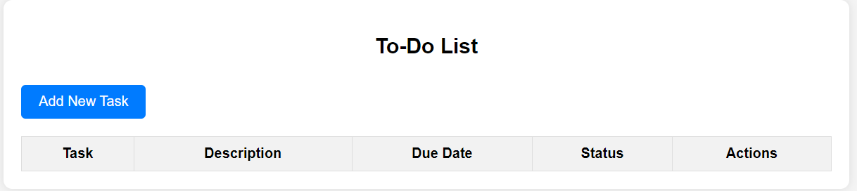

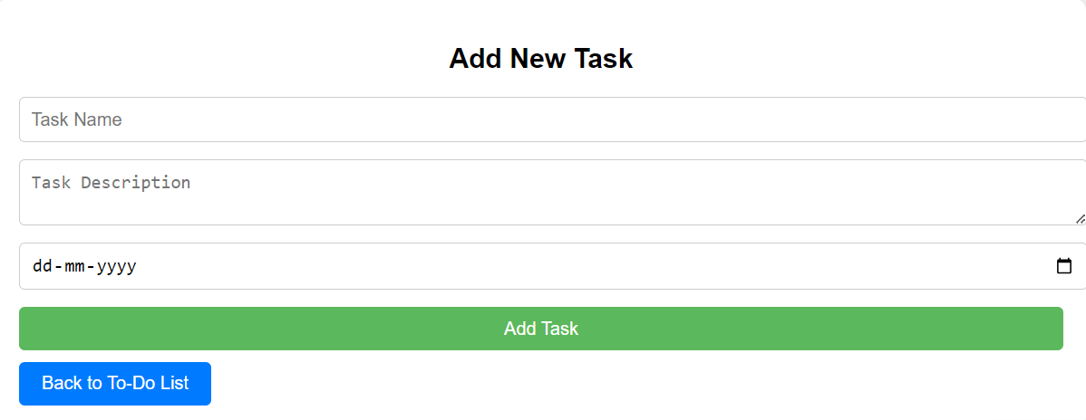

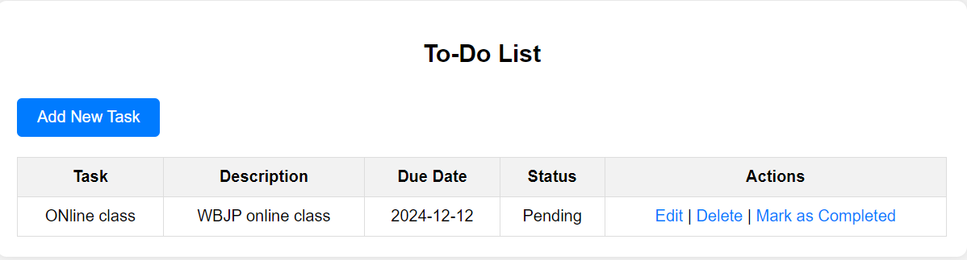

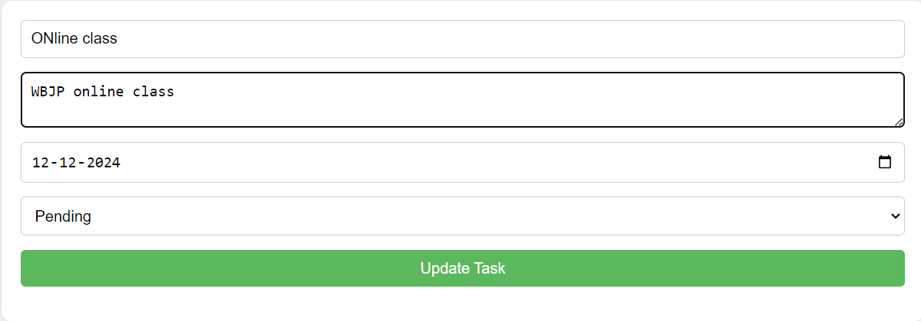

After Delete or Mark as completed

